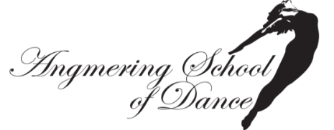

KIM MIRCETA-NASH
07782148830

TICKET ORDER FORM- ‘Welcome to Wonderland’
Full price tickets £14 Concessions £12 (children under 10yrs and Senior citizens)
Please fill in the form below by placing the amount of tickets you require for each night

 | First choice |  |  | Second choice
 | Number of  Full price  Tickets | Number of  Concession |  | Number of  Full Price  Tickets | Number of  Concessions | OFFICE USE  ONLY
Saturday 7th  October  6.45pm |  |  | Saturday 7th October  6.45pm
Sunday 8th  October  .1.30pm |  |  | Sunday 8th  October  1.30pm

Please return this form ASAP as all tickets are allocated on a first come first serve basis. As Saturday night is very popular please try to give an alternative night if possible. If you require a wheel chair space please indicate in the box above for which night and how many.

TOTAL NUMBER OF FULL PRICED TICKETS REQUIRED …………….
TOTAL NUMBER OF CONCESSIONS ………………………

AMOUNT PAID £………………

SIGNED ………………………. [PRINT CHILD’S NAME]…………………………..

All money for tickets must be paid to Angmering School of Dance
BACS payments Sort code: 403920 ACC:71505963 or cash sent with form.
Tickets will be returned via your child week prior to show or they will be available for you to collect at box office before the performance. Please place order form and payment in the envelope provided with the name of your child printed on the front.

……………………………………………………………………………………………………………

For queries regarding ticket allocation, please contact Louisa Hughes by either email or text on aglhughes@gmail.com or 07889 031719.

